Spatiotemporal Representation Learning for Driving Behavior Analysis: A Joint Perspective of Peer and Temporal Dependencies

*Submitted in fulfilment of the requirements for the degree of Bachelor of Technology*

*by*

Atishay Jain (167108)

Ankit Kumar (167107)

Pridhvi Malhotra (167129)

*Under the esteemed guidance of*

**Dr. R.B.V. SUBRAMAANYAM**



Department of Computer Science and Engineering National Institute of Technology Warangal

2019-2020

# APPROVAL SHEET

The project work entitled **Spatiotemporal Representation Learning for Driving Behavior Analysis: A Joint Perspective of Peer and Temporal Dependencies** by Atishay Jain, Ankit Kumar, Pridhvi Malhotra is approved for the degree of Bachelor of Technology in Computer Science and Engineering at National Institute of Technology Warangal during the year 2019-20.

**Examiners**

——————————

——————————

——————————

——————————

——————————

**Supervisor**

——————————

Dr. R.B.V. SUBRAMAANYAM

Professor, CSE Dept.

Date: Place:

# DECLARATION

We declare that this written submission represents our ideas in our own words and where others’ ideas or words have been included. We have adequately cited and referenced the original sources. We also declare that we have adhered to all principles of academic honesty and integrity and have not misinterpreted or fabricated or falsified any ideas/ data / fact / source in our submission. We understand that any violation of the above will be a cause for disciplinary action by the Institute and can also evoke penal action from the sources which have thus not been properly cited or from whom proper permission has not been taken when needed.

—————————————————

(Signature)

Atishay Jain 167108

Date:

—————————————————

(Signature) Ankit Kumar 167107

Date:

—————————————————

(Signature)

Pridhvi Malhotra 167129

Date:

### ACKNOWLEDGEMENT

We would like to express heartfelt gratitude and regards to our project guide **Dr. R.B.V. SUBRAMAANYAM,** Department of Computer Science and Engineering, NIT Warangal. We convey a humble thanks to him for his valuable cooperation, support and suggestion throughout the project work which made this project successful. I shall remain indebted throughout my life for his noble help and guidance.

We are thankful to all the faculties of the Department of Computer Science and Engineering, NIT Warangal, for their encouraging words and valuable suggestions towards the project work. Last but not the least we want to acknowledge the contribution of our parents, family members, and friends for their constant and never-ending motivation.

We would like to take this opportunity to express our gratitude to the people who have been instrumental in the successful completion of the project.

Atishay Jain (167108)

Ankit Kumar (167107)

Pridhvi Malhotra (167129)

#### ABSTRACT

As the world is growing at a great pace, so are humans' dependencies on electronic gadgets and automobiles. Transportation has been one such field which has revolutionized and changed the life of millions. The major changes from walking in past to multi-featured vehicles in present sets our path to autonomous driving in future. As every major change comes with it's pros and cons, so to ensure driving remains a safe activity, assessing a driver's behavior in different circumstances and providing improvement measures becomes a necessity.

Our project aims to achieve significant knowledge from various drives conducted in a variety of situations to analyse the driver's behavior. We are using a Peer and Temporal Aware Representation Learning based framework (PATRL) for driving behavior analysis using GPS trajectory data. We ﬁrst detect the driving operations and states of each driver from their GPS traces. Then, we derive a sequence of multi-view driving state transition graphs from the driving state sequences, in order to characterize a driver’s driving behaviors that vary over time. In addition, we develop a peer and temporal-aware representation learning method to learn a sequence of time-varying yet relational vectorized representations from the driving state transition graphs..

### CONTENTS

1. Introduction 7
   1. Twitter Sentiment Analysis 7
   2. Traditional Approach of Sentiment Analysis 8
   3. Limitations of Traditional Methods 8
2. Related Work 9
3. Problem Statement 10
4. Attributes Definition 11
5. Model Framework 14
   1. Architecture 14
   2. SVM Prediction model 15
6. Experimental Results 17
   1. Data Pre-processing 17
      1. Data Visualisation 17

6.2.2 Data Cleaning 18

* 1. Experimental Setup 19
  2. Observation and Result Analysis 19
     1. Confusion matrices 20

1. Conclusion 23
2. References 24

**CHAPTER 1**

#### INTRODUCTION

**Driving Behavior Analysis**

As driving comprises of various speed and direction related operations, such as acceleration, decceleration, keeping constant speed, turning left, turning right, moving straight. By analysing driving behaviors we can try to provide driving assistance, enhance driving comforts, develop intelligent and resiliant transportation systems, assessing driver's performances and enhance traffic safety. Our project aims to obtain quantitative representation of driver's behavioral trend from his raw GPS trajectories.

The studies conducted till date have scope of improvements as some of them are based on biased and expensive data sources, others considering data which might have privacy issues e.g. usage of CAN bus data, hence GPS data remains the best alternative. However CAN bus data is more accurate to quantify driving operations, but it receives data from equipments installed in vehicles and even consist of information which driver might not be willing to reveal. Due to the pervasiveness of GPS sensors, GPS data can be collected from location based apps (e.g. Google Maps), that are granted permissions by usem themselves. Thus we are convinced to use GPS data for our task. It is highly promising to use high-resolution widely-available GPS trajectories with representation learning for the task of driving behavior analysis.

**CHAPTER 2**

#### RELATED WORK

Prior studies in driving behaviors analysis can be categorized into:

1. **Causal Analysis**: Researchers identify the causal factors of driving behaviors and explain how these factors inﬂuence road safety [20].
2. **Predictive Analysis**: Researchers mine the patterns from driving data and apply machine learning models (e.g., SVM, naive Bayesian, etc.) to predict risky scores [36].

(iii) **Descriptive Analysis**: Transportation experts deﬁne measurements (e.g., harsh or frequent acceleration/braking, sharp turn, acceleration before turn) based on transportation theory to describe driving behaviors [4].

## CHAPTER 3

#### PROBLEM STATEMENT

##### In our project, we explore the problem of automated driving behavior profiling with GPS traces. Formally, given a driver (a vehicle) and corresponding GPS trajectories, we aim to find a mapping function that takes the GPS trajectories as inputs, and outputs a sequence of time-varying yet relational vectorized representations in order to quantify the dynamics of the driver’s driving behavior. We formulate this problem as a task of spatio-temporal representation learning. Essentially, we first construct a sequence of driving state transition graphs from GPS trajectories, and then learn the latent representations of driving behavior from the graphs.

**CHAPTER 4**

**ATTRIBUTES DEFINITION**

TABLE 1: Summary of notations.

|  |  |
| --- | --- |
|  |  |
| *φt* | The latitude at time t |
|  |  |

1. *Driving State*: It is a tuple with two values, the first being speed status and second as direction status. Eg. <acceleration, turning-left>.

2.*State Transition Grpahs*: Driver's movement from one driving state to another is depicted as state transition graph which inherently is a directed graph.

## CHAPTER 5

#### MODEL FRAMEWORK

##### Architecture

Data extraction

Extracted data

Fit it in SVM and predict results for the testing data

Extracting repost diﬀusion network from the data

Combining these results

Prediction of sentiment polarities using traditional method

Twitter

Extracting historical behaviour features from the data

Final Output

Extracting repost cascade tree from the data

*Architecture of our proposed model*

The above figure depicts the architecture of our model (based on the data collection method of Lei Wang[25]). The data is used for two different prediction algorithms and then combined later. First, we take each tweet individually in the dataset to predict it’s sentiment polarity individually by using the traditional textual information based sentiment analysis method.

Then we also take the same data and extract all it’s features based on repost cascade trees, repost diffusion networks and historical behaviour between the users. We fit all this data into a nonlinear SVM (Support Vector Machine) with an RBF Kernel to predict whether a sentiment reversal occurs between a tweet and it’s retweet or not.

Finally, we combine the data obtained from these two prediction methods and combine them in an algorithm called SentiDiff[25], to get more accurate predictions of the sentiments of the tweets.

##### SVM Prediction Model

**Support Vector Machine -** A Support Vector Machine (SVM) is a discriminative classifier formally defined by a separating hyperplane. In other words, given labeled training data (supervised learning), the algorithm outputs an optimal hyperplane which categorises new examples. In two dimensional space this hyperplane is a line dividing a plane in two parts where in each class lay in either side.

We use three different SVM’s to train the same data based on different set of features: repost cascade tree features, repost diffusion network features and historical behaviour features. The prediction result on the testing data is combined from these three SVM’s to predict if a sentiment reversal occurs between a tweet and it’s retweet or not.

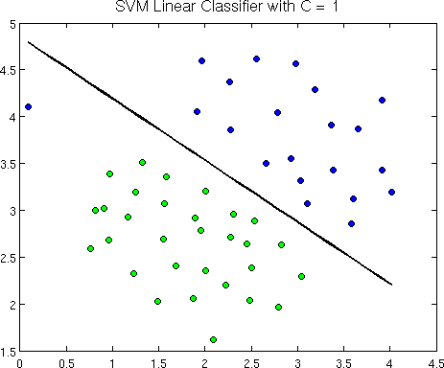

An example of SVM. *Image source:* <http://openclassroom.stanford.edu/MainFolder/> DocumentPage.php?course=MachineLearning&doc=exercises/ex7/ex7.html

## CHAPTER 6

#### EXPERIMENTAL RESULTS

##### Data Pre-processing

The dataset that we extract from Twitter only consists of Tweets and their network. The features that we require to train our SVM model are not present. So, we have to manually look at the given dataset and note down the features that are required for our use. We extract only those features that are needed for our use.

##### Data Visualisation

For a better understanding of the kind of data we worked with, here are some samples of collection of tweets that we used to train our data in the from of trees. This helps us visualise how sentiment diffusion takes place in the data.

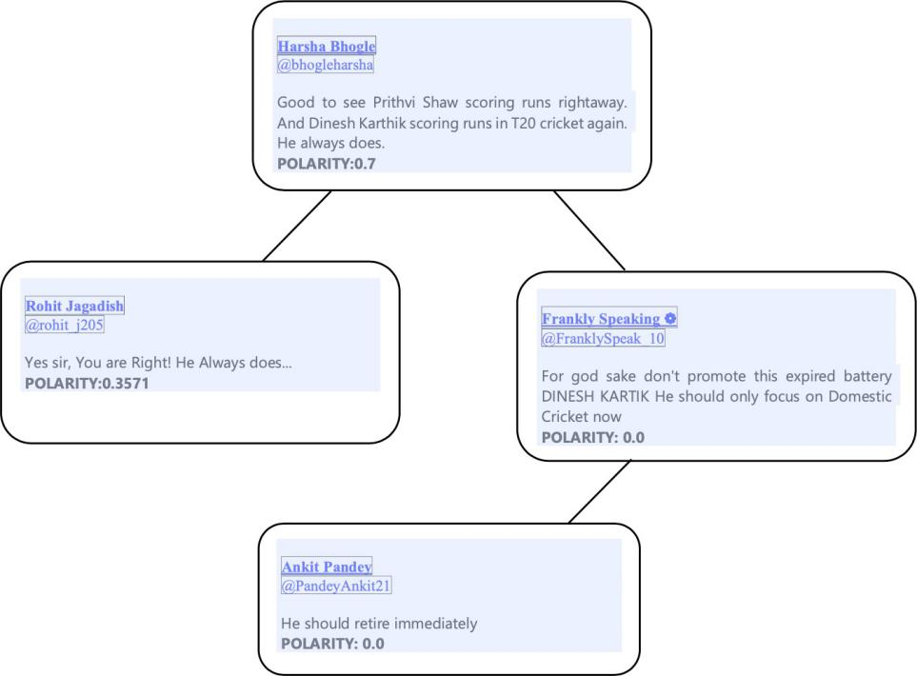

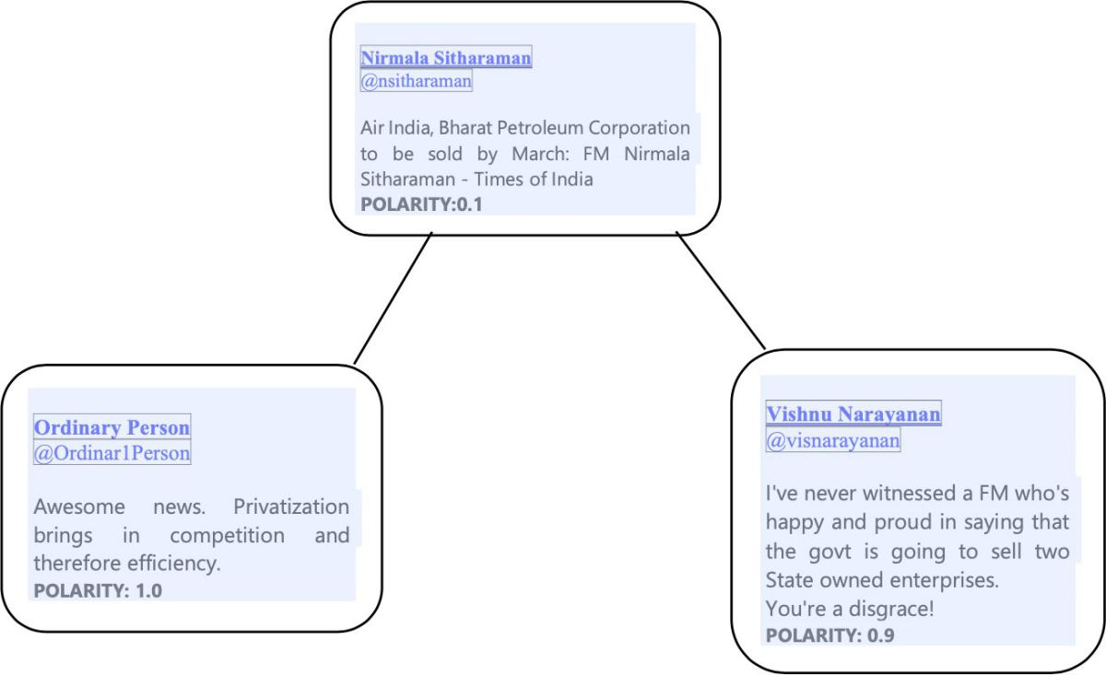

##### Data cleaning

The tweets that we get directly from twitter contain a lot of emojis, misspelled words, slangs, acronyms and modal particles because of their casual form. We cannot give such text directly for sentiment analysis using textual information based sentiment analysis method. So, we have to clean it before we use it. We use the following code for this purpose.

##### Experimental Setup

We run our programs on python 2.7 on x64 machine using sklearn, tweepy, textblob, and standard plotting packages with 8GB RAM, 2.3 Ghz i7 CPU. Majority of the work implemented was using the pandas data frame.

The data was partitioned into two parts - train set and test set in the ratio 7:3, or approx. 700 train values and 300 test values, and the model was trained using the train set and evaluated using the test set.

##### Observation and Result Analysis

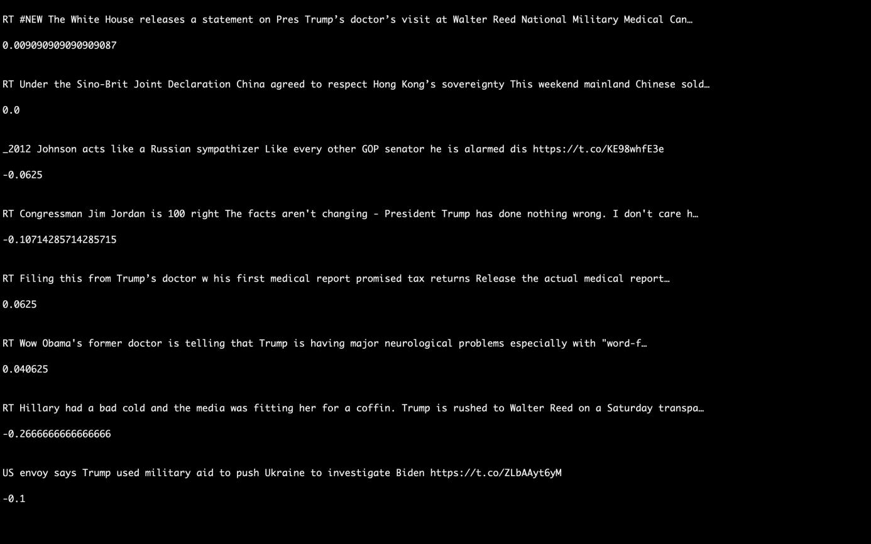

The final result is the sentiment polarities predicted by our algorithm. A portion of the output is shown below:

We make a pie chart to show how the tweets have been classified.

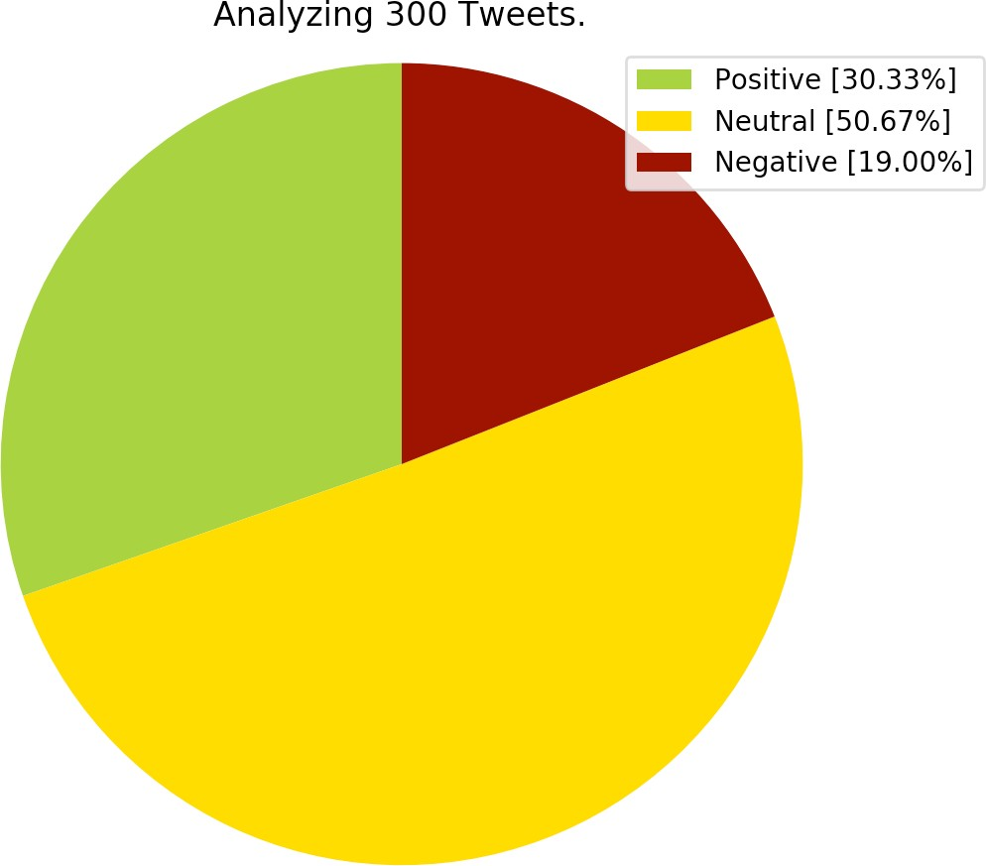

##### Confusion Matrices

This is the confusion matrix for sentiment analysis using traditional method. As we can see from the confusion matrix, some of the tweets that

were predicted to have a certain sentiment polarity are not actually having that same sentiment polarity. The accuracy is 94.33 %.

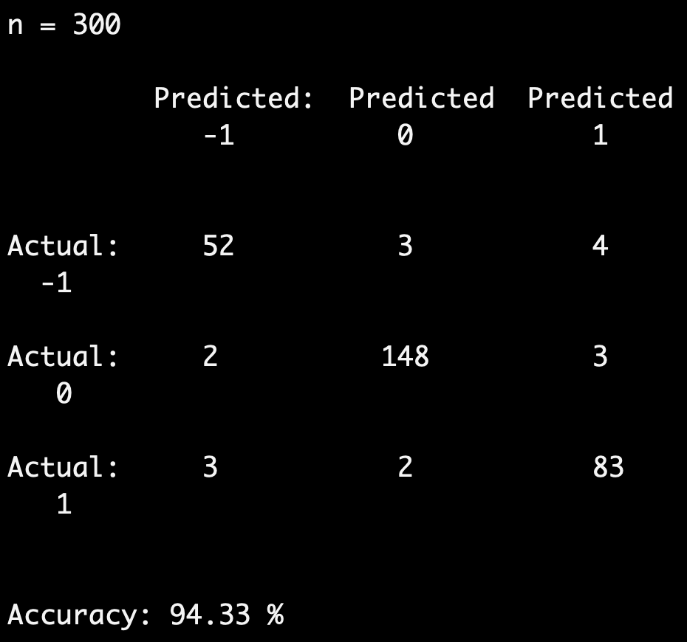

The confusion matrix after combining textual information data with sentiment diffusion analysis is shown below. Here we can see that the accuracy is 96.00%.

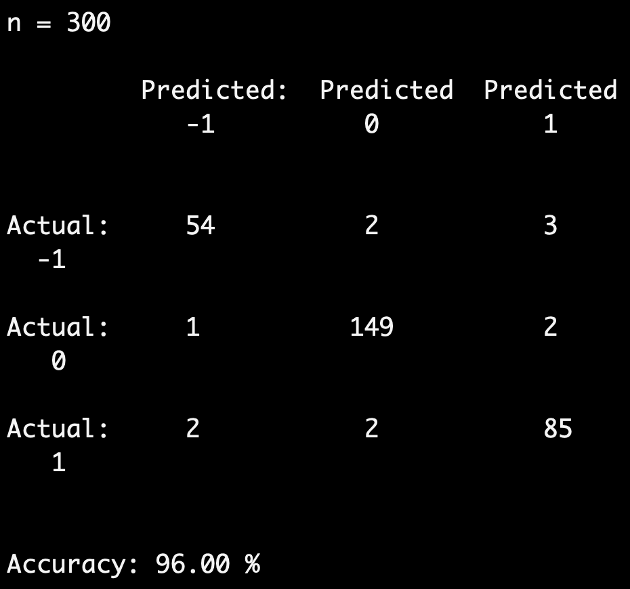

Thus, we conclude that our algorithm increases the accuracy of prediction of sentiment polarities by 1.67%.

## CHAPTER 8

#### CONCLUSION

Sentiment analysis of the data available online on various social media platforms has received great attention in recent years, and various methods of sentiment analysis have been advanced. In this work, we focussed on sentiment diffusion patterns in twitter message networks and combined it with the traditional approaches. The results show that indeed after combining sentiment diffusion patterns information, the accuracy of prediction has increased.

To improve upon this accuracy, in the future, instead of using SVM for sentiment reversal prediction, we will use deep learning for the prediction. Also, more amount of data can be used.

In conclusion, as more and more data gets generated on Twitter, the interrelationships between the tweets becomes more complex. Therefore, to completely understand the sentiments of people, new techniques will have to be thought of constantly.

## CHAPTER 7

#### REFERENCES

1. H. Li, L. Dombrowski, and E. Brady, “Working toward empowering a community: How immigrant-focused nonprofit organiSations use twitter during political conflicts,” in Proceedings of the 2018 ACM Conference on Supporting Groupwork. ACM, 2018, pp. 335–346.
2. D. Tang, B. Qin, F. Wei, L. Dong, T. Liu, and M. Zhou, “A joint

segmentation and classification framework for sentence level sentiment classification,” IEEE/ACM Transactions on Audio, Speech, and Language Processing, vol. 23, no. 11, pp. 1750–1761, 2015.

1. H. Wang, D. Can, A. Kazemzadeh, F. Bar, and S. Narayanan, “A system for real-time twitter sentiment analysis of 2012 us presidential election cycle,” in Proceedings of the ACL 2012 System Demonstrations. Association for Computational Linguistics, 2012, pp. 115–120.
2. D. Paul, F. Li, M. K. Teja, X. Yu, and R. Frost, “Compass: Spatio temporal sentiment analysis of us election what twitter says!” in Proceedings of the 23rd ACM SIGKDD International Conference on Knowledge Discovery and Data Mining. ACM, 2017, pp. 1585–1594.
3. F. Bravo-Marquez, E. Frank, and B. Pfahringer, “Annotate-sample-

average (asa): A new distant supervision approach for twitter sentiment analysis,” in 22nd European Conference on Artificial Intelligence (ECAI), vol. 285. IOS Press, 2016, pp. 498–506.

1. B. Pang, L. Lee et al., “Opinion mining and sentiment analysis,” Foundations and Trend s ⃝ R in Information Retrieval, vol. 2, no. 1–2, pp. 1–135, 2008.
2. K.-L. Liu, W.-J. Li, and M. Guo, “Emoticon smoothed language models for twitter sentiment analysis,” in Proceedings of the Twenty- Sixth AAAI Conference on Artificial Intelligence, 2012.
3. J. Zhao, L. Dong, J. Wu, and K. Xu, “Moodlens: an emoticon-based sentiment analysis system for chinese tweets,” in Proceedings of the 18th ACM SIGKDD international conference on Knowledge discovery and data mining. ACM, 2012, pp. 1528–1531.
4. A. Go, R. Bhayani, and L. Huang, “Twitter sentiment classification

using distant supervision,” CS224N Project Report, Stanford, vol. 1, no. 12, 2009.

1. D.-T. Vo and Y. Zhang, “Target-dependent twitter sentiment clas-

sification with rich automatic features.” in IJCAI, 2015, pp. 1347– 1353.

1. E. Cambria, “Affective computing and sentiment analysis,” IEEE Intelligent Systems, vol. 31, no. 2, pp. 102–107, 2016.
2. D. Tang, F. Wei, N. Yang, M. Zhou, T. Liu, and B. Qin, “Learning sentiment-specific word embedding for twitter sentiment classification,” in Proceedings of the 52nd Annual Meeting of the Association for Computational Linguistics, 2014, pp. 1555–1565.
3. K. Schouten and F. Frasincar, “Survey on aspect-level sentiment analysis,” IEEE Transactions on Knowledge and Data Engineering, vol. 28, no. 3, pp. 813–830, 2016.
4. J. Zhao and X. Gui, “Comparison research on text pre-processing methods on twitter sentiment analysis,” IEEE Access, vol. 5, pp. 2870– 2879, 2017.
5. S. Symeonidis, D. Effrosynidis, and A. Arampatzis, “A comparative evaluation of pre-processing techniques and their interactions for twitter sentiment analysis,” Expert Systems with Applications, 2018.
6. M. Thelwall, K. Buckley, and G. Paltoglou, “Sentiment in twitter events,” Journal of the Association for Information Science and Technology, vol. 62, no. 2, pp. 406–418, 2011.
7. N.Du,Y.Liang,M.Balcan,andL.Song,“Influence function learning in information diffusion networks,” in International Conference on Machine Learning, 2014, pp. 2016–2024.
8. M. Tsytsarau, T. Palpanas, and M. Castellanos, “Dynamics of news events and social media reaction,” in Proceedings of the 20th ACM SIGKDD international conference on Knowledge discovery and data mining. ACM, 2014, pp. 901–910.
9. S. Stieglitz and L. Dang-Xuan, “Emotions and information diffu- sion

in social media sentiment of microblogs and sharing behav- ior,” Journal of Management Information Systems, vol. 29, no. 4, pp. 217–248, 2013.

1. Y.Fu,Y.Ge,Y.Zheng,Z.Yao,Y.Liu,H.Xiong,andJ.Yuan,“Sparse real

estate ranking with online user reviews and offline moving behaviors,” in 2014 IEEE International Conference on Data Mining (ICDM). IEEE, 2014, pp. 120–129.

1. Y. Zheng, “Methodologies for cross-domain data fusion: An overview,” IEEE transactions on big data, vol. 1, no. 1, pp. 16–34, 2015.
2. J. Tang and A. Fong, “Sentiment diffusion in large scale social

networks,” in 2013 IEEE International Conference on Consumer Elec- tronics (ICCE). IEEE, 2013, pp. 244–245.

1. M. Miller, C. Sathi, D. Wiesenthal, J. Leskovec, and C. Potts,

“Sentiment flow through hyperlink networks,” in ICWSM, 2011.

1. X. Zhang, D.-D. Han, R. Yang, and Z. Zhang, “Users participation and social influence during information spreading on twitter,” PloS one, vol. 12, no. 9, p. e0183290, 2017.
2. Lei Wang, Jianwei Niu, Shui Yu, “SentiDiff: Combining Textual Information and Sentiment Diffusion Patterns for Twitter Sentiment Analysis”, Journal of Latex Class Files, Vol. 14, No. 8, August 2018